**Survey Management Sketches:**

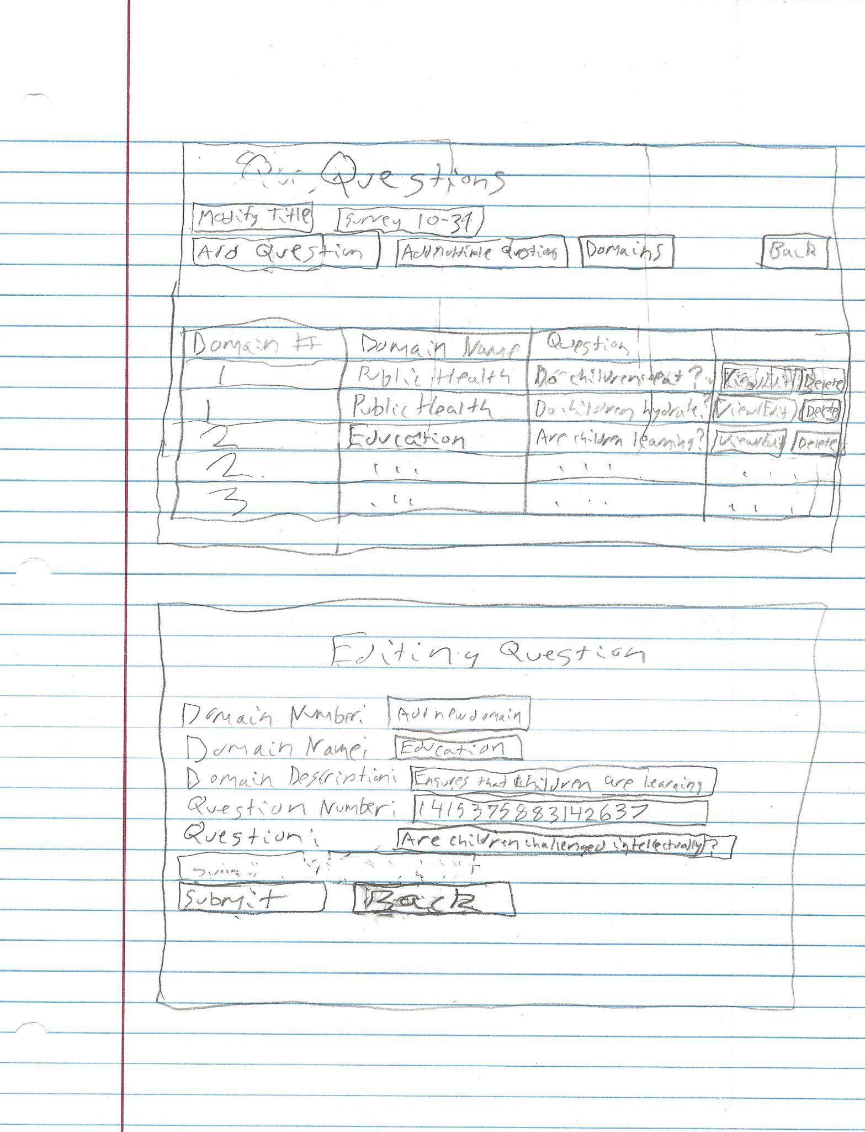

The purpose of the sketches is showing completed templates of the 2 above wireframes. Photo by Matthew Campbell

**Survey Management Wireframes:**

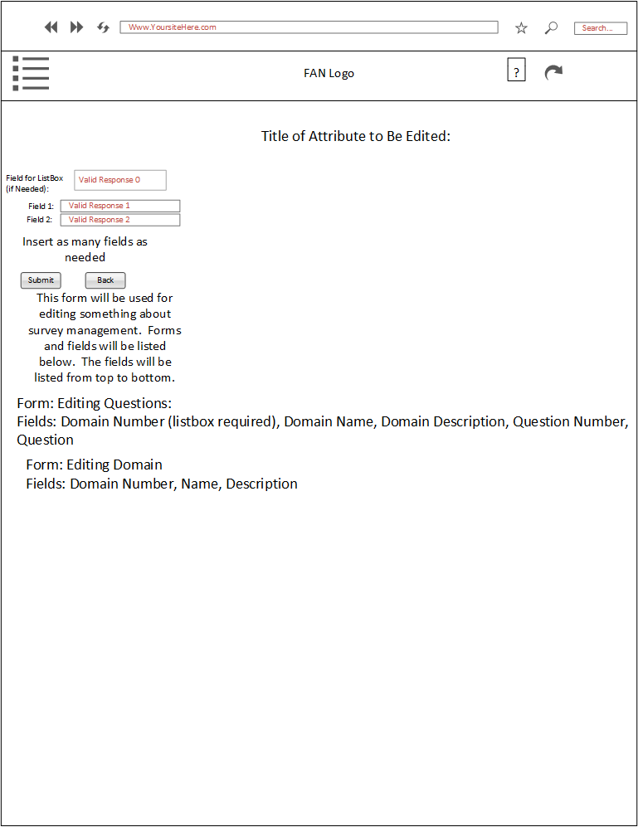

This is the template for editing something on the survey (by Matthew Campbell). The fields that will be used for each form are below the textboxes.

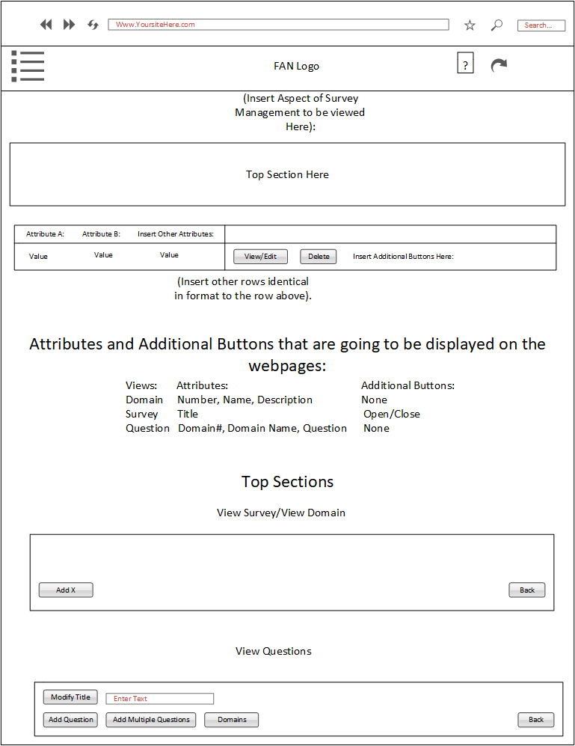

This is the template that will be used for viewing particular parts of the survey whenever a superadmin wants to edit the survey. The attributes and additional buttons that will be displayed are displayed below the table. The top sections that will be used are at the bottom of the picture. Photo by Matthew Campbell